Library Management System in Java

Using MySQL as Backend Storage

Submitted By:

|  |
| --- |
| Atharva Deshmukh  229311049  IOT  B  III Semester |

To:

Dr. Abhay Sharma



**Introduction**

Welcome to our Java-based Library Management System project, a comprehensive solution designed to streamline library operations and enhance user experience. This system integrates with a MySQL database and offers a dual login system, providing distinct features for both librarians and students.

For students, our system simplifies the process of searching for books and keeping track of their issued books. With a user-friendly interface, students can easily access the library's collection and monitor their borrowing history.

Librarians, on the other hand, have access to a wider range of features to manage the library efficiently. They can view a list of all currently issued books, issue books to students, process book returns, delete books from the database, add new student records, view student details, add new books to the collection, and view information about the library's holdings.

This project aims to improve the overall library experience, making it more convenient for both students and librarians to interact with the library's resources. It promotes effective book management, enhances the student experience, and simplifies administrative tasks for library staff.

**Problem Statement**

To create a library management system in Java using MySQL as a database to store the data for the library system including two separate login for Librarian and Student and different features such as issue books and return books.

The project will help us understand about Java as a language and the connectivity that can be built with MySQL.

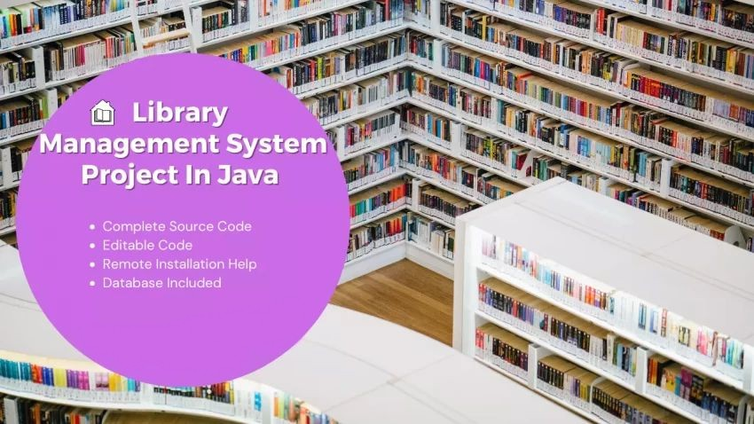

**Methodology**

The methodology for developing the Library Management System project with MySQL and dual login system (librarian and student) involves several key steps.

**1. Project Planning and Scope Definition:**

- Identify the project's objectives and define its scope.

- Create a project plan with timelines and milestones.

**2. Requirements Gathering:**

- Gather detailed requirements from library staff, students, and other stakeholders.

- Identify specific functionalities and features needed for the system.

**3. System Design:**

- Create a high-level system architecture that includes components like the user interface, application logic, and database.

- Define the data structure for the MySQL database, including tables for books, students, issued books, etc.

- Design the user interfaces for both students and librarians.

**4. Database Design:**

- Create the database schema based on the design from the previous step.

- Define relationships between tables.

- Implement the necessary indexes and constraints.

**5. Frontend Development:**

- Develop the user interfaces for both students and librarians using Java's GUI libraries.

- Implement search functionality for students to find books and view their issued books.

**6. Backend Development:**

- Develop the backend logic for the system.

- Implement features such as book issuance, return, and CRUD (Create, Read, Update, Delete) operations for books and student records.

- Ensure that appropriate security measures are in place, such as user authentication and authorization.

**7. Integration with MySQL:**

- Develop database connectivity modules to interact with the MySQL database.

- Ensure data is stored, retrieved, and updated accurately in the database.

**8. Documentation:**

- Create user manuals and technical documentation for both end-users (students and librarians) and developers.

- Document the database schema, code, and APIs.

This methodology ensures a systematic approach to developing the Library Management System, covering all aspects of project planning, design, development, testing, deployment, and ongoing support. It aims to create an efficient and user-friendly system for managing library resources while ensuring data security and integrity.

**Hardware/Software**

**Software:**

* Apache NetBeans IDE 19
* MySQL Workbench 8.0
* MySQL server 5.5.40
* mysql-connector-java-5.1.40-bin.jar
* mingw64 redistributable
* Windows 11 Home
* Packages:
  1. JavaFrame
  2. JavaFX
  3. Java.swing
  4. Java.sql
  5. Java.util

**Hardware:**

* HP Victus 15-8GB,Radeon 6500M(4GB),Ryzen 7
* MySQL server